* **The Design Methodology**
* Like I stated in my preliminary lab report I used 3 gates and a LED and additionally I used 4 resistances and 3 more LEDs to visualize inputs. I started to prepare my setup with connecting **74HC163 4-bit counter** as it is shown in the datasheet of it. After doing that I connected my gates with counter outputs in the order of my circuit diagram and additionally I connected a resistance for each counter output and connected those resistance to red LEDs. I connect the grounds to the blue line and all Vcc to the red line at the edges of the breadboard. Finally, I connected a resistance to the output of the circuit and a green LED to that resistance to visualize the output. My truth table, Karnaugh map, algebraic simplifications, circuit diagram and gates I used are shown below, respectively.

Truth Table

|  |  |  |  |  |  |
| --- | --- | --- | --- | --- | --- |
| S | C | R | H(S,C,R) |  | Minterms |
| 0 | 0 | 0 | 0 | 1 |  |
| 0 | 0 | 1 | 0 | 1 |  |
| 0 | 1 | 0 | 0 | 1 |  |
| 0 | 1 | 1 | 0 | 1 |  |
| 1 | 0 | 0 | 1 | 0 |  |
| 1 | 0 | 1 | 0 | 1 |  |
| 1 | 1 | 0 | 1 | 0 |  |
| 1 | 1 | 1 | 1 | 0 |  |

Karnaugh Map

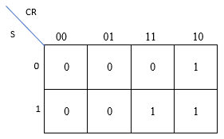

Sum of products( minterms)

**Logic Schematic Diagram**

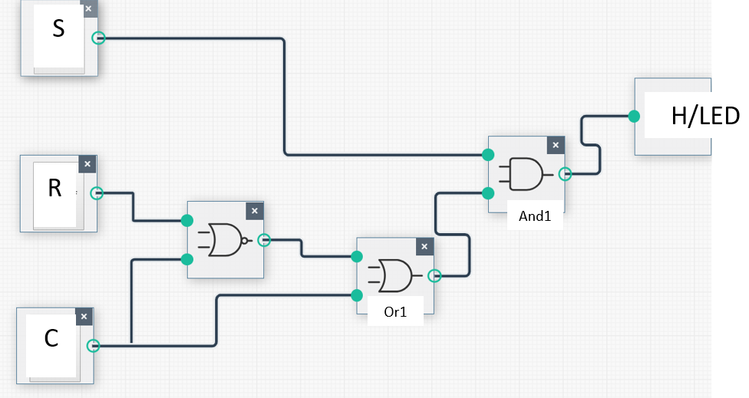

* Like I mentioned in my prelab report I connected the pins as I the diagrams below

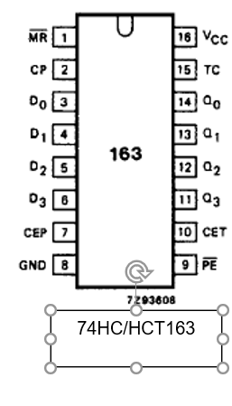 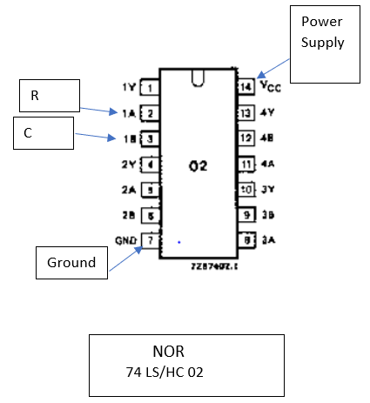

Ground

Signal Generator

Power supply

Power supply

Power supply

Power supply

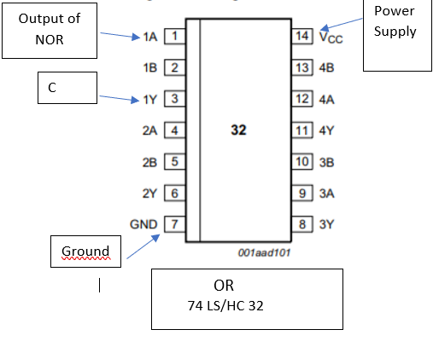 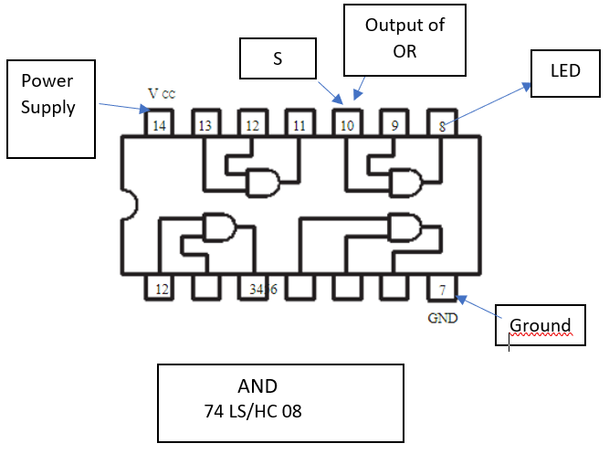

* **Results**

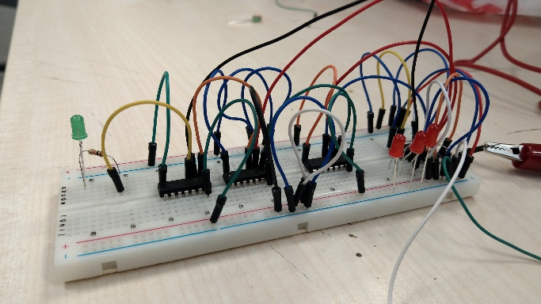 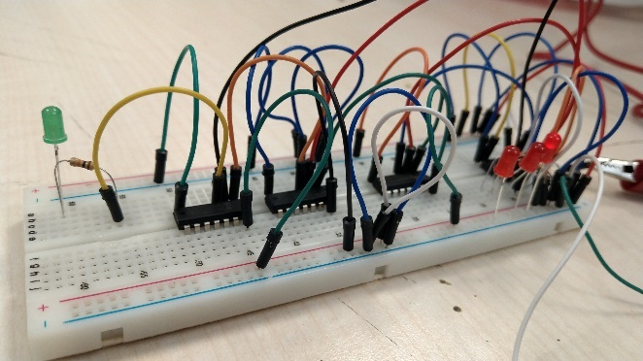

S:0 C:0 R:0 H:0 S:0 C:0 R:1 H:0

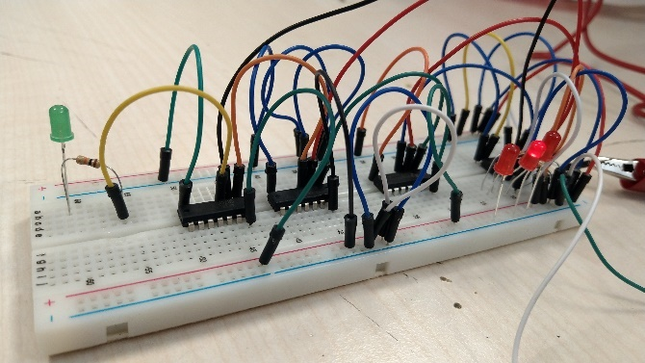 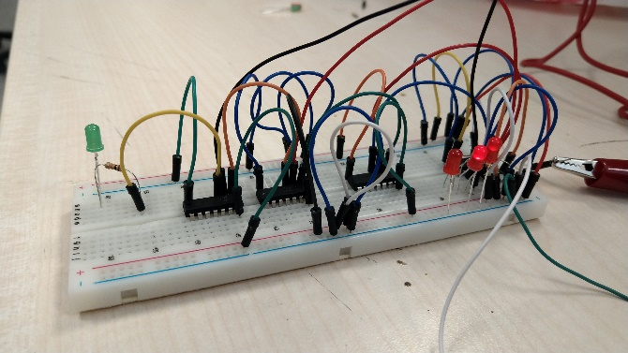

S:0 C:1 R:0 H:0 S:0 C:1 R:1 H:0

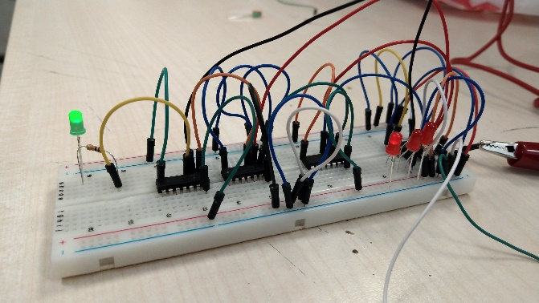 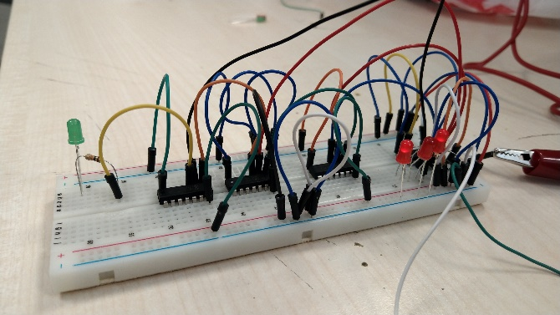

S:1 C:0 R:0 H:1 S:1 C:0 R:1 H:0 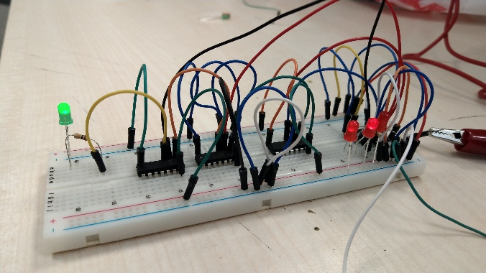 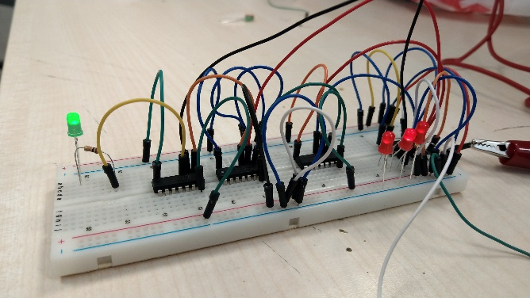

S:1 C:1 R:0 H:1 S:1 C:1 R:1 H:1

* Because of using the signal generator and 4-bit converter we obtain the current behaves in a way like 0 and 1 s so LEDs are on and off according to these combinations like we though while preparing the preliminary lab report.
* **Conclusion**
* I learnt how to use 4-bit converter which I thought very hard when I read the datasheet but in the it seems much easier than what I expected. I learnt how to use LEDs in circuit and it is possible to burn them so because of that I used resistors not to burn other LEDS. Most import thing I learnt is how to read the datasheets and according to that how to use the components. Thanks to this week’s class and lab I learn how to write and read Karnaugh Map which makes my circuit easier.